CSS 3 by Thapa

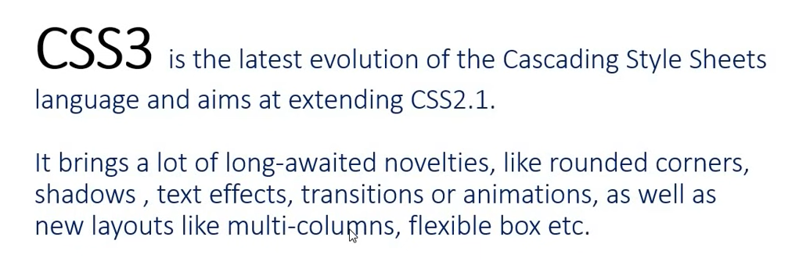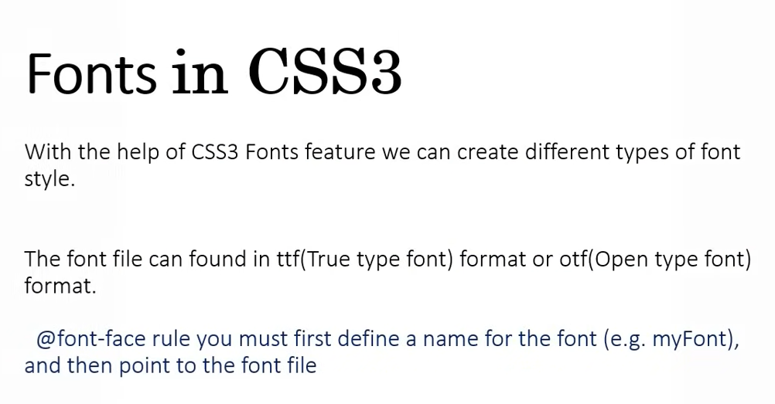

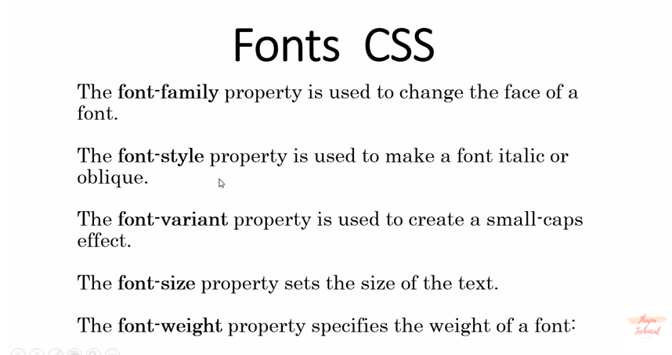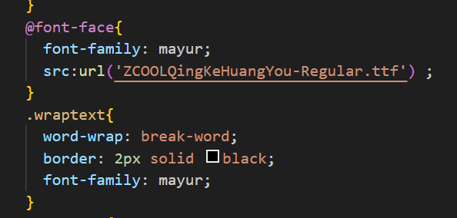download font from google and copy file to our folder.

Position –

Parent compo chi position relative asel ani tyala dharun child/internal compo chi position left/right/bottom/bottom right karun set karata yeil

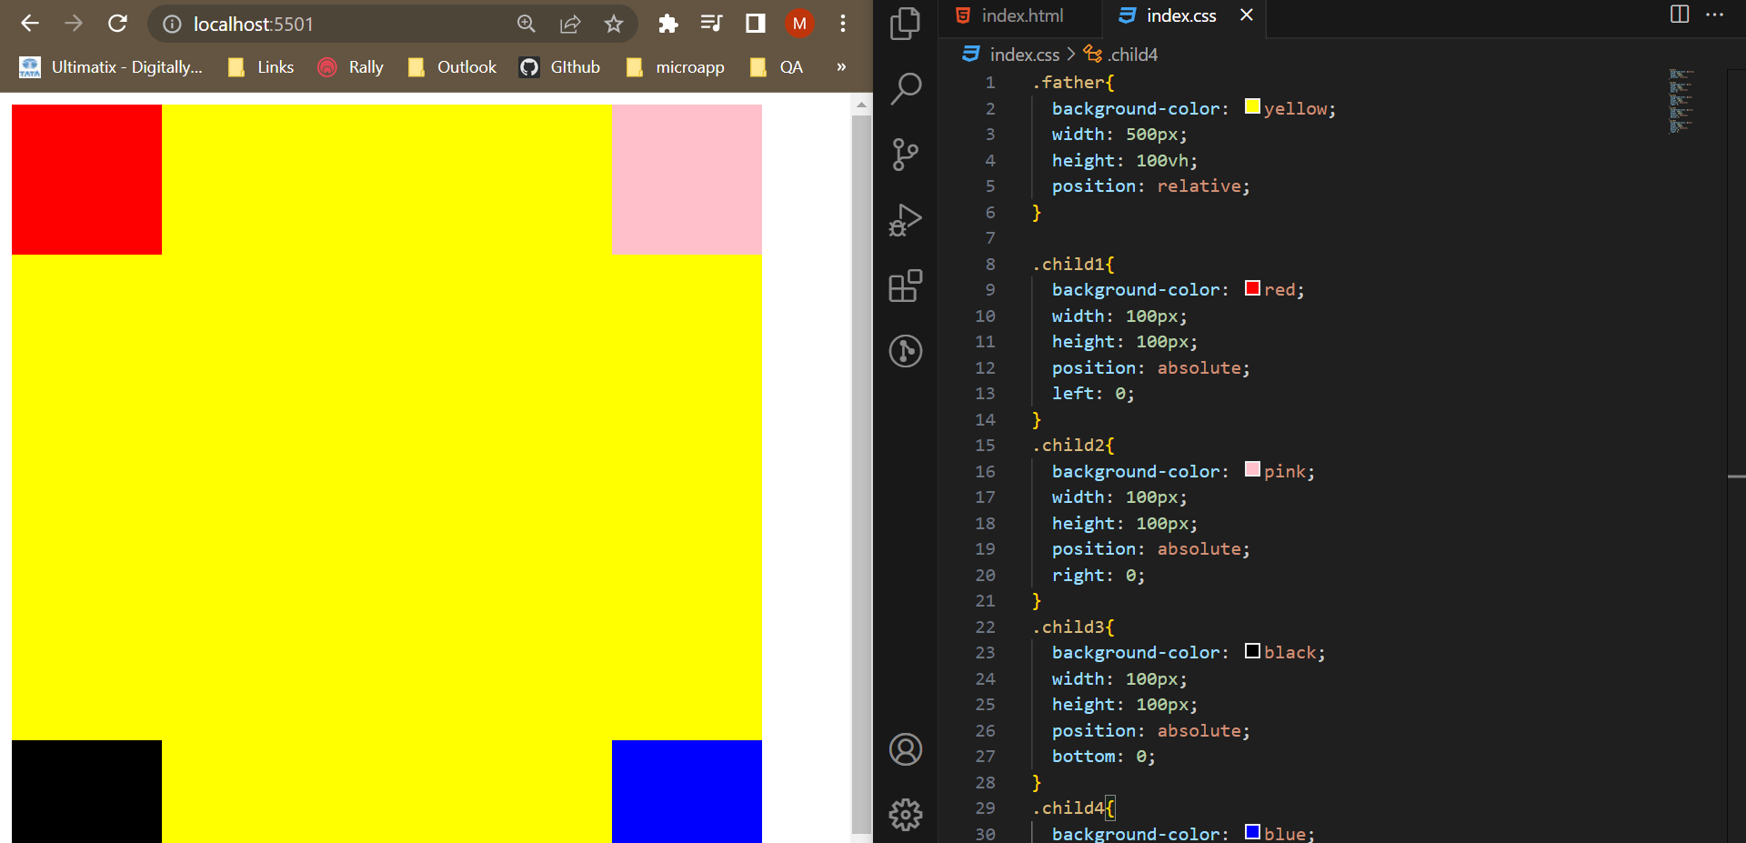

Z index –position dilyavar cha use hoil

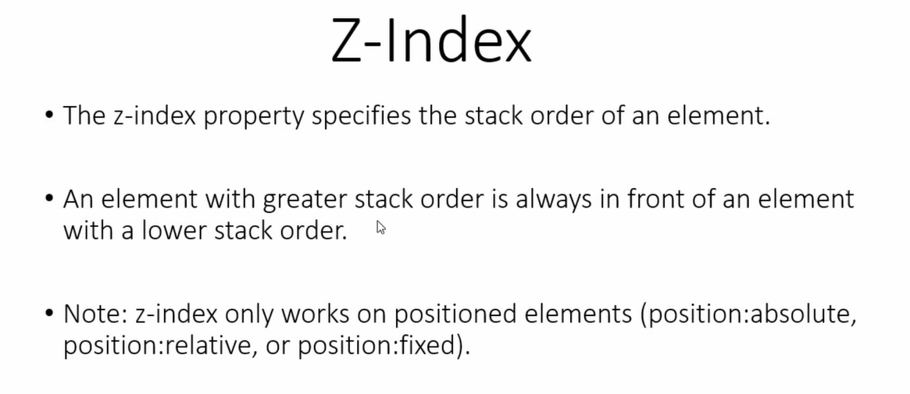 jyacha jast to varti

Css float –

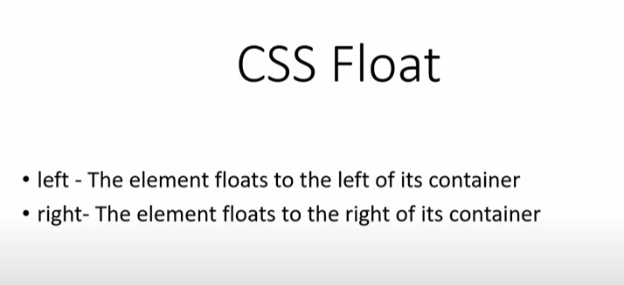

Jevha header madhe menu eka bajula ek pahije tevha, parent element chya compare left kivha right hot

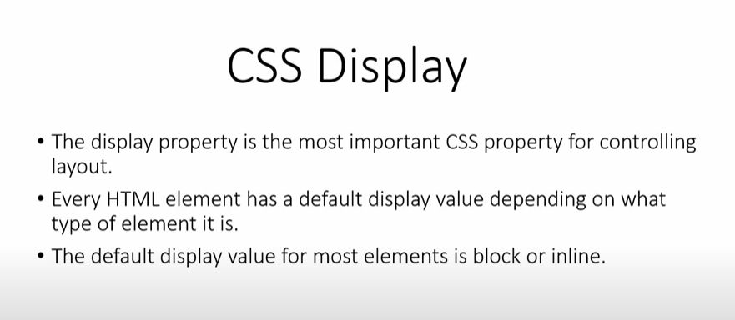

Display –

Inline – jevdi jaga pahije tevdicha ghete ani next element la jaga det

Block – purn jaga get

Inline-block – horizontally jaga det next element la , vertically block karat border paryant

None –

Flex -

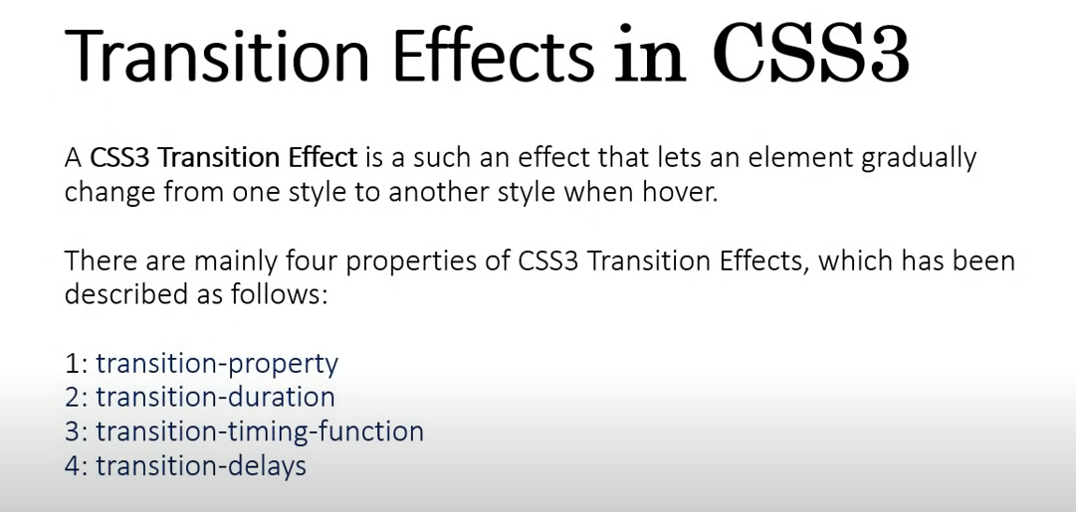

Animation aur transition are same but animation page load zalyavar lagech hot ani transition hover kelyavar hot

Animation -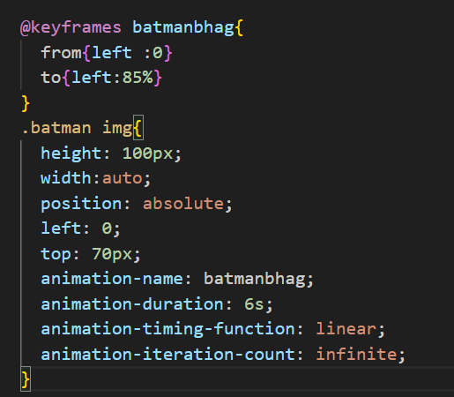

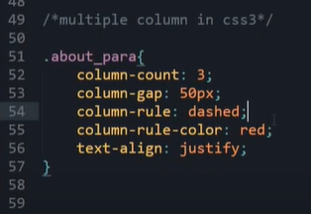

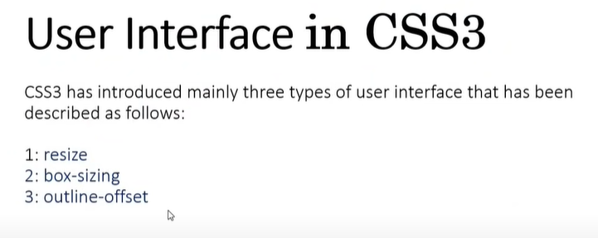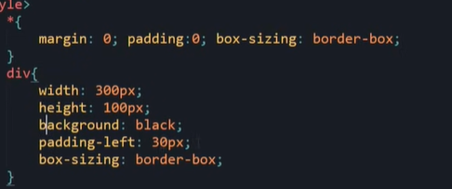

Box sizing - border-box === padding ani marging ignore karel

Transform – instead of margin and padding we use

Transition –

Linear gradient –

Flex – ek row me multiple column

Grid – ek column me multiple row